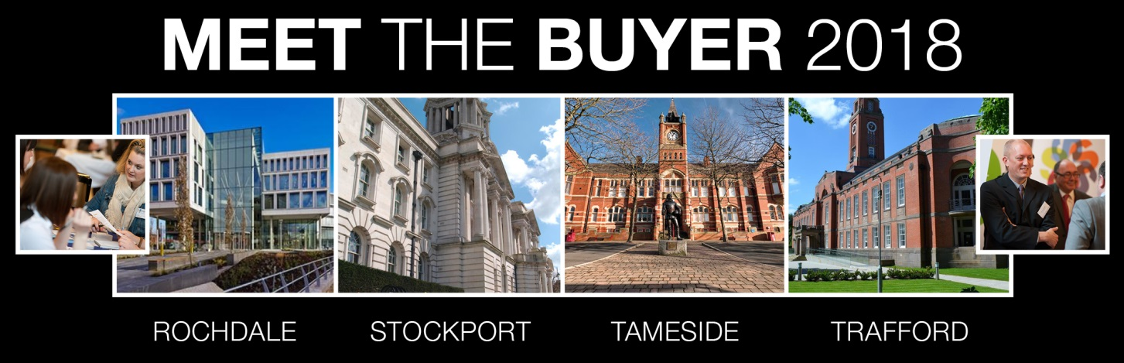

BOOKING FORM
Meet the Buyer – 22nd November 2018 Rochdale Town Hall - Great Hall

To request an appointment with any of the buying teams participating please read the ‘Supplier Information Pack’ and then complete and return the form below. The deadline for returning all booking forms is 5pm on 18th October.

As stated in the ‘Supplier Information Pack’ we are looking to match suppliers with those companies who have identified a purchasing requirement. Please note, due to the popularity of the event, you will need to prioritise companies that you would like to meet. Please identify no more than 4 companies.

If we successfully match you with any purchaser/s we will contact you via email by Wednesday 7th November with appointment details.

It is essential all fields are completed.
Company Name Contact Name

Company Address Email Address – all correspondence relating to Meet the Buyer including appointment details will be sent to this address

Telephone

Please describe in no more than 100 words the products and services that your company supplies:

Please indicate which of the buying team(s) listed below you would like to meet in order of preference (1 = highest). Please identify no more than 4 and please note we cannot guarantee appointments with all teams. Priority will be given to those able to meet the requirements of the buying teams.

Please note a number of the purchasing teams are looking for similar goods and services as in previous years. Therefore priority will be given to those suppliers who have not met with the purchasing team at previous Meet the Buyer events.

Company | Priority |  | Company | Priority
Crescent Purchasing Consortium |  |  | STAR (Professional)
Hopwood Hall College |  |  | Stockport Homes
Rochdale Boroughwide Housing |  |  | Totally Local Company
STAR (People) |  |  | UA 92
STAR (Place)

Please indicate whether you would prefer morning or afternoon appointment(s):
AM (9:30am – 12:00pm) ☐ PM (12:50pm – 4.00pm) ☐

We will endeavour to meet your preferred time but this cannot be guaranteed.

Thank you for completing this form.

Please save a copy of your form and send to info@meetthebuyer.org.uk by 5pm on 18th October 2018. If your form is not received by this date we will be unable to offer you any appointments

If you don’t receive an acknowledgement you should assume we haven't received your booking form and contact us on 01706 927000

